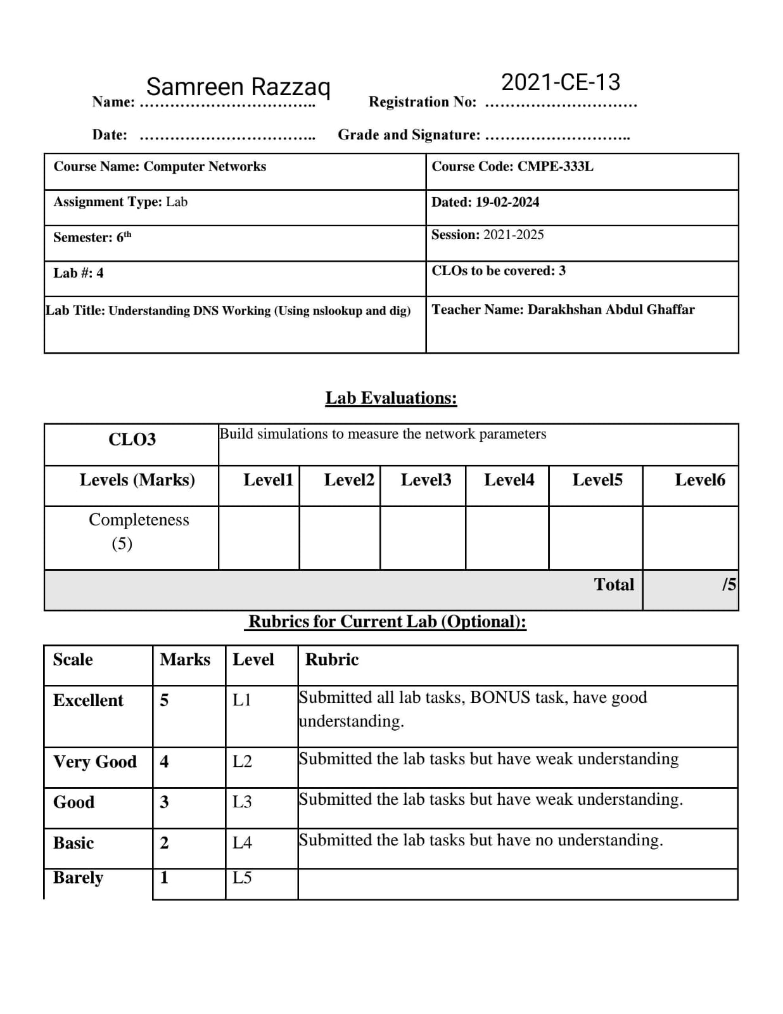

**Lab Exercise 1:**

**Do the following (and write down the results):**

1. 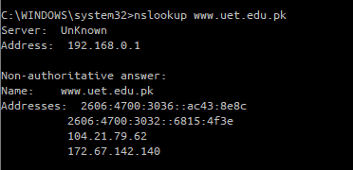Run nslookup to obtain the IP address of a Web server of UET.

The IP address is 192.168.0.1

1. Run nslookup to determine the authoritative DNS servers for UET.

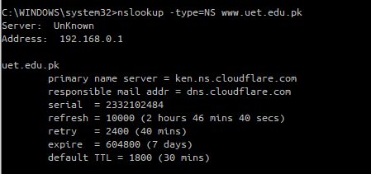

The IP address is 192.168.0.1

1. 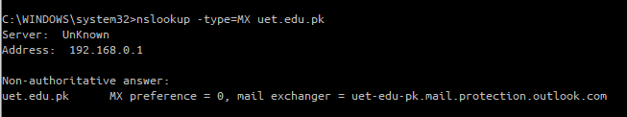Run nslookup to determine the mail servers for UET.

The IP address is 192.168.0.1

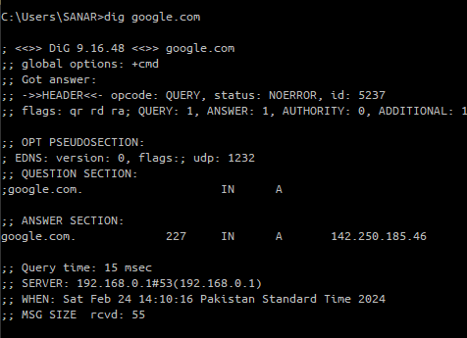**Lab Exercise 2:**

**Perform the following tasks:**

**1.** Run this command: dig google.com

**a.** What IP addresses are associated with google.com?

142.250.185.46

**b.** Run the same command again. Note that the numbers in the second column of the

Answer Section change. Wait a few seconds and run it a third time. What do the

numbers in the second column represent?

**Solution:**

TTL (Time to leave in seconds)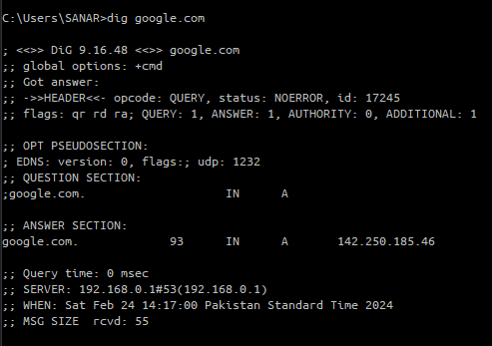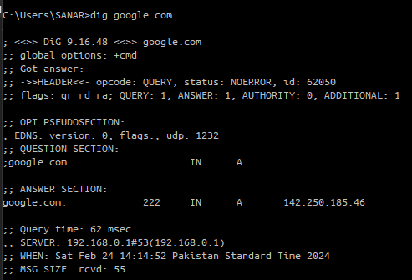.

**2.** Run this command: dig google.com ns

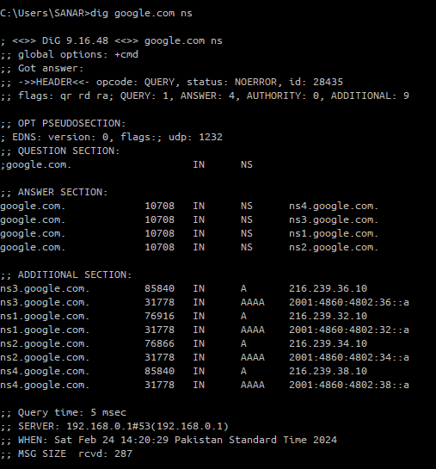**a.** What is different about the information provided by this version of the command?

**b.** How many name servers are there for google.com?

There are 4 name servers.

1. Run this command google.com mx. What information does the output of this version of the command provide?

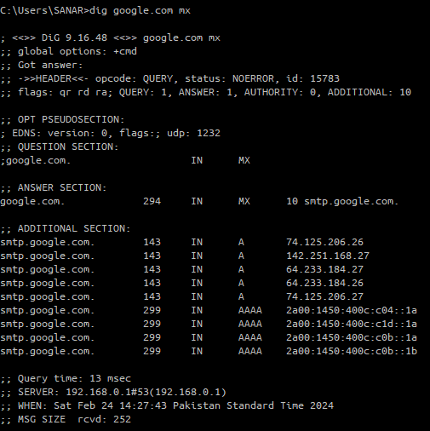**Solution:**

Mail Servers.

1. 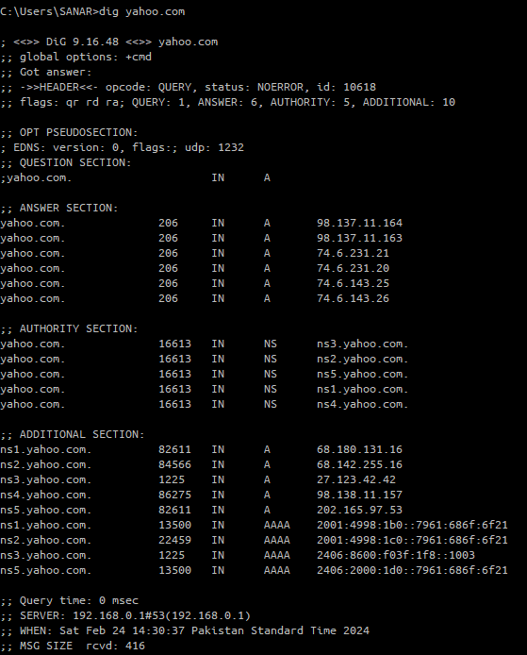**a.** Run a command to find the number of IP addresses that are associated with

yahoo.com.

There are 6 IP address.

**b.** Run a command to find the number of name servers that there are for yahoo.com.

There are 5 name servers.

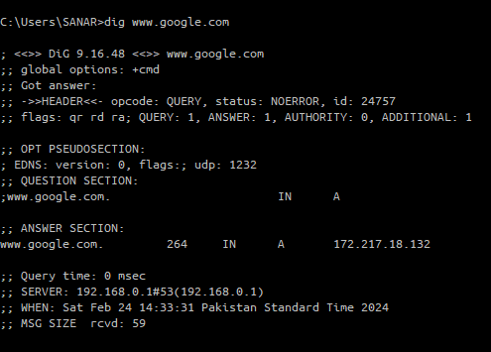**5.** Run this command: dig www.google.com

**a.** What IP addresses are associated with [www.google.com](http://www.google.com)?

Only 1 IP address.

**b.** How many name servers are there for [www.google.com](http://www.google.com)?

Only 1 name server.

**c.** What relationship (if any) do you see between google.com and [www.google.com](http://www.google.com)?

They have same udp:1232.

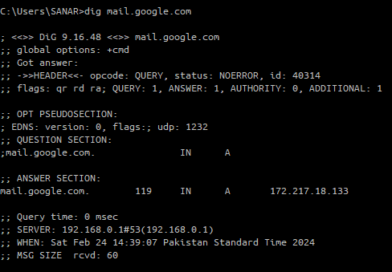**6.** Run this command: dig mail.google.com

**a.** How many IP addresses are associated with mail.google.com?

Only 1 IP address.

**b.** What relationship (if any) do you see between google.com and mail.google.com?

They have same udp:1232 and network id 172.217.18.133.

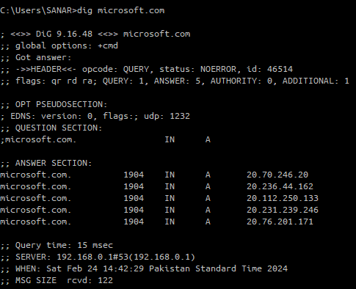**7.** Run the command: dig microsoft.com

Note the query time

**a**.Repeat the command and note of the query time.

Query time: 15 msec

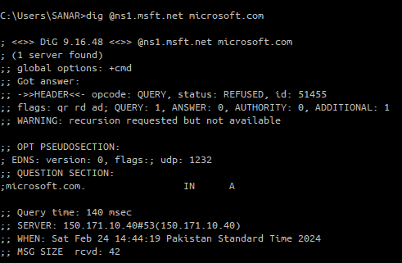

**b.** Run the command: dig @ns1.msft.net microsoft.com and note the query time

Query time: 140 msec

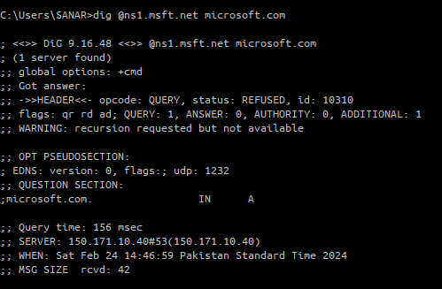**c.** Repeat the previous command and note the query time.

Query time: 156 msec

**d.** Explain the reasons for any observed differences in the query times for each of the commands in parts a. - d.

Query time change by 16 msec.

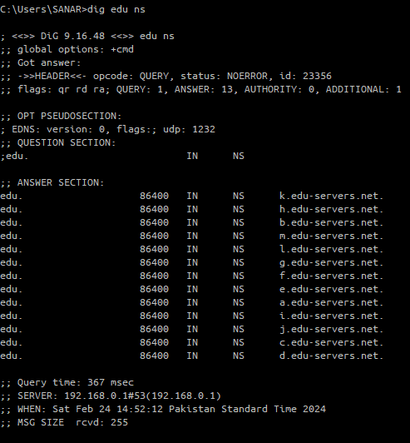**8.** Run each of the following commands and describe what the output represents in each case (also specify what each domain represents).

**9.** dig edu ns

Give 13 name servers for edu.

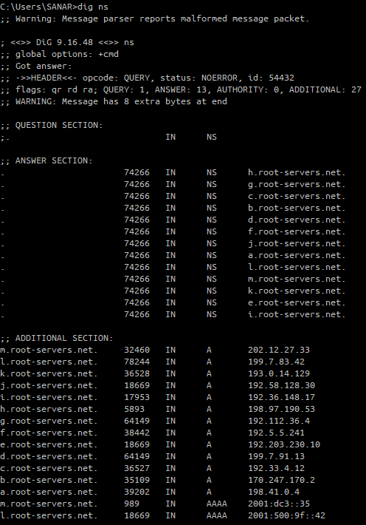

**10.** dig ns

Give 13 name servers for root.

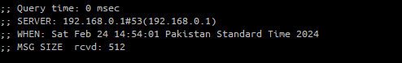

**11.** Run this command: dig www.mit.edu +trace

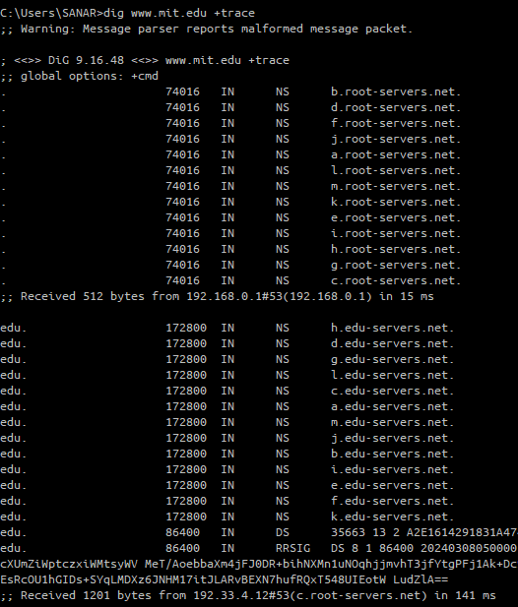**a.** Summarize what information is provided by the output of the command that uses the trace option. (Some of the info from 8.a. will be useful in answering this question.)

**b.** Give the specific path of name servers that provide the information requested in this query.

**Solution:**

13 root servers, 13 edu servers, 8 akam servers.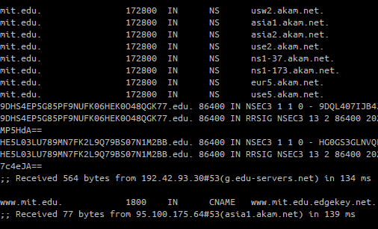

**c.** Repeat the command several times. Look for differences in the outputs when the

command is repeated and explain them.

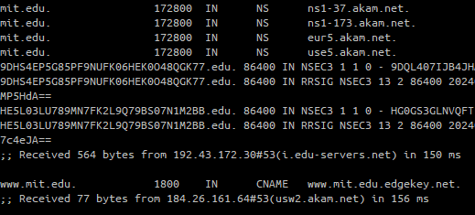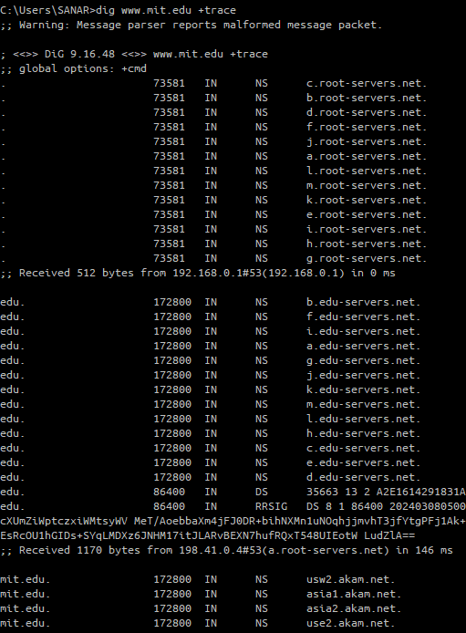Difference in TTL (Time to live) is observed